1.

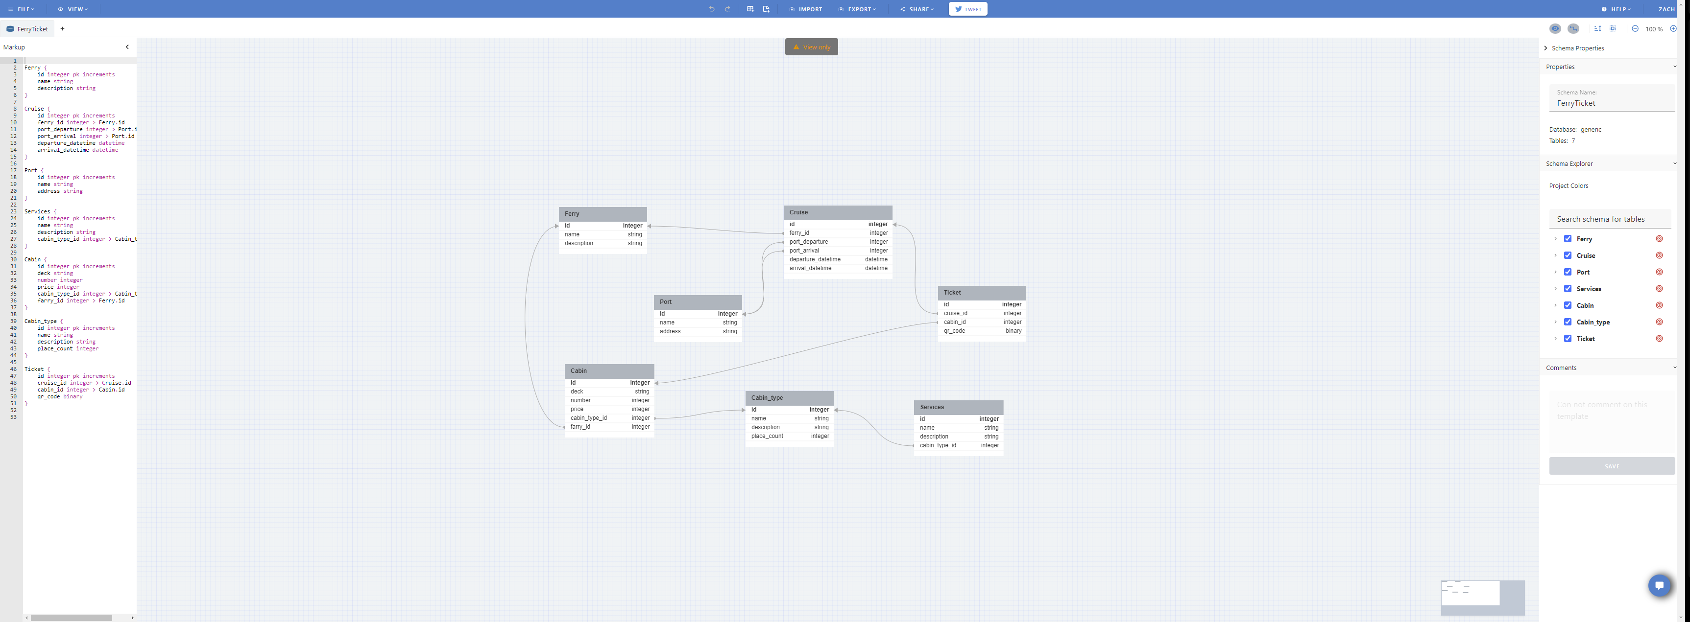

Services has an integer primary key id, a string name, a string description, and a integer cabin type id.

Cabin type has an integer primary key id, a string name, a string description, and a integer place count.

Cabin has an integer primary key id, a string deck, a integer number, a integer price, a integer foreign key cabin type id, and a integer foreign key ferry id.

Ferry has an integer primary key id, a string name, and a string description.

Ticket has an integer primary key id, a integer foreign key cruise id, a integer foreign key cabin id, and a binary qr code.

Cruise has an integer primary key id, a integer foreign key ferry id, a integer foreign key port departure, a integer foreign key port arrival, a datetime departure datetime, and a datetime arrival datetime.

Port has an integer primary key id, a string name, and a string address.

Services is taking cabin type id from the cabin type table and using it as a foreign key in a one-to-one relation.

Cabin type gives the cabin type id to the cabin table in a one-to-one relation. Cabin type id is this table's primary key.

Cabin uses ferry id and cabin type id as foreign keys, making it have a many-to-one relationship with the cabin type and ferry tables.

Ferry has a one-to-many relationship with cruise and cabin.

Ticket has a many-to-one relationship with cabin and cruise.

Cruise has a one-to-one relationship with ticket, and a many-to-one relationship with ferry and port.

Port has a one-to-one relationship with cruise.

2. SELECT * FROM Cruises AS c INNER JOIN Ferry AS f ON c.ferry_id = f.id INNER JOIN Cabin AS ca ON ca.ferry_id = f.id INNER JOIN Cabin_type AS ct ON ca.cabin_type_id = ct.id INNER JOIN Services AS s ON s.cabin_type_id = ct.id WHERE c.port_departure = ‘Charlevoix’ AND c.port_arrival = ‘South Haven’ AND s.name = ‘Cocktail’ UNION SELECT address FROM Port WHERE name = ‘Charlevoix’ OR name = ‘South Haven’ ;

3. I think the Port table could have been better. It should have a dock number for which dock it is at in the port because ports can have multiple docks or docking stations. It should also include whether the port is a home port or a port of call. The address type is integer, but it should be varchar which allows numbers and special characters to be used.